# Exercise: Introduction to HTML and CSS

Problems for exercises and homework for the ["HTML and CSS" course @ SoftUni](https://softuni.bg/trainings/3122/html-and-css-september-2020/). Submit your solutions in the SoftUni Judge system at <https://judge.softuni.bg/Contests/1136/Introduction-to-HTML-and-CSS>.

## Simple HTML Page

Create a web page like the following:

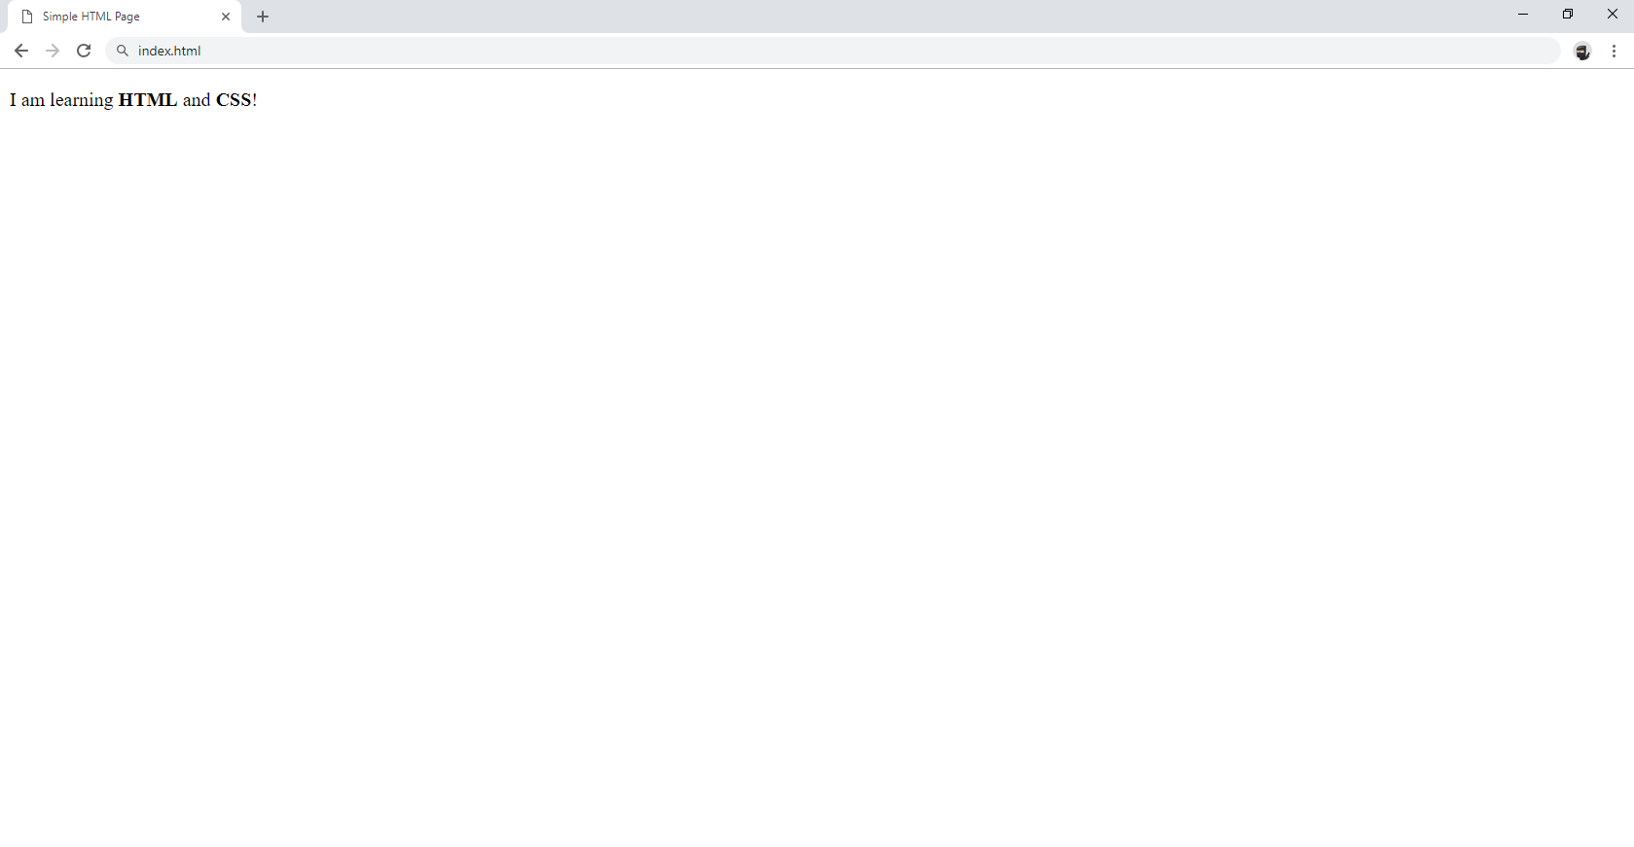

### Constraints

* Change the document **title** to *Simple HTML Page*
* Use **paragraph** tag for plain text and **strong** tag for bold text

## Tags Cardio - Paragraphs

Create a web page like the following:

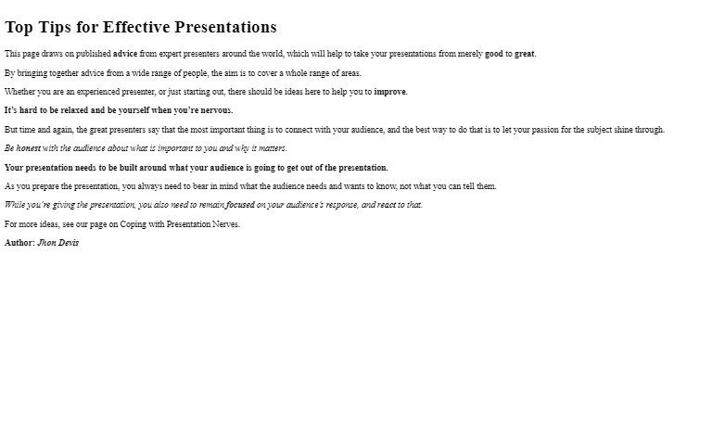

### Constraints

* Change the document **title** to Paragraphs
* Use the h1 tag for heading
* Use p tags for each line of the text
* See the screenshot and use strong and em tags where needed

## Single Article Page

Create a web page like the following:

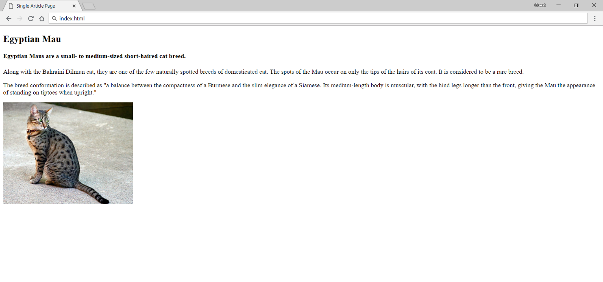

### Constraints

* Change the document **title** to Single Article Page
* Create an article with several items inside
  + Use h2 and h4 tags for headings
  + Use p tags for the text
  + Use img tag for the photo

## Tags Cardio - Lists

Create a web page like the following:

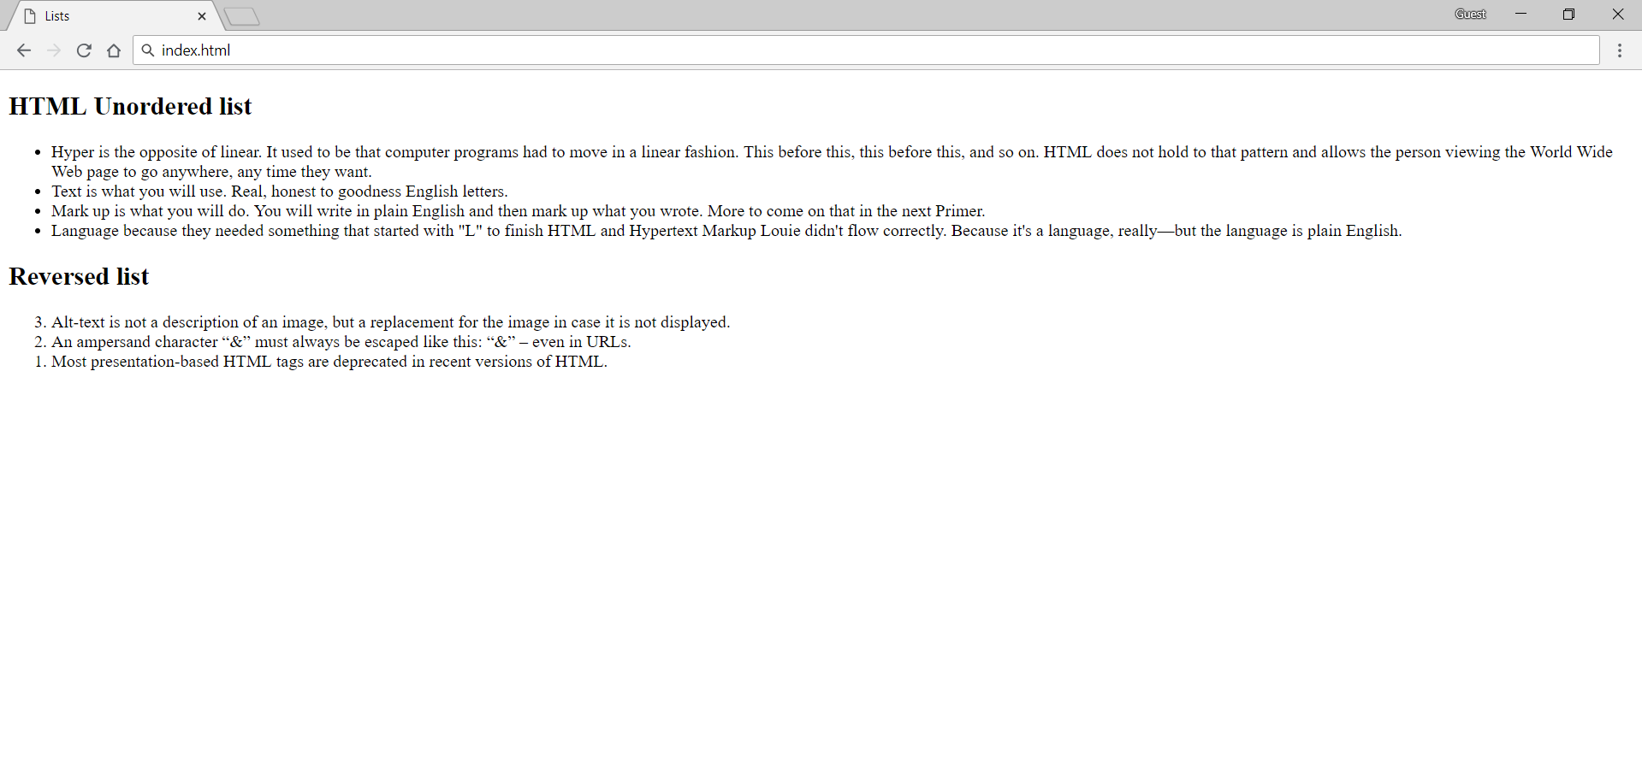

### Constraints

* Change the document **title** to Lists
* Add section with two articles inside (for each list)
* Each article must have a h2 heading
  + Use ul for unordered list
* Add four list items
  + Use ol reversed for ordered reversed list
* Add three **list** items

## Tags Cardio - Nested Lists

Create a web page like the following:

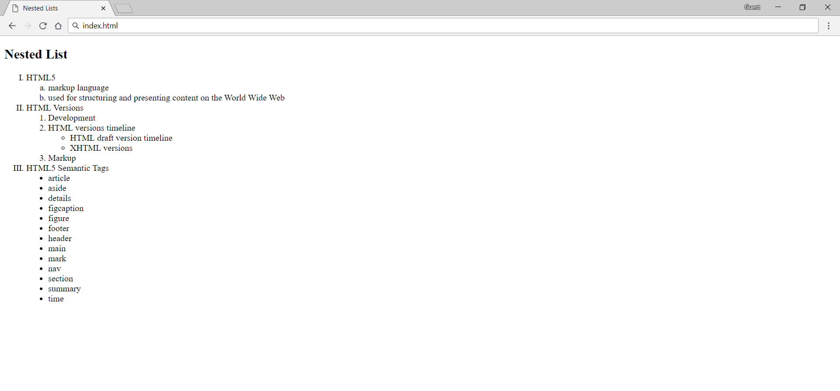

### Constraints

* Change the document **title** to Nested Lists
* Use h2 tag for heading
* Use different types for **ordered** and **unordered** lists
* See the screenshot and use different type attribute as circle, disc etc.

## Tags Cardio - Table

Create a web page like the following:

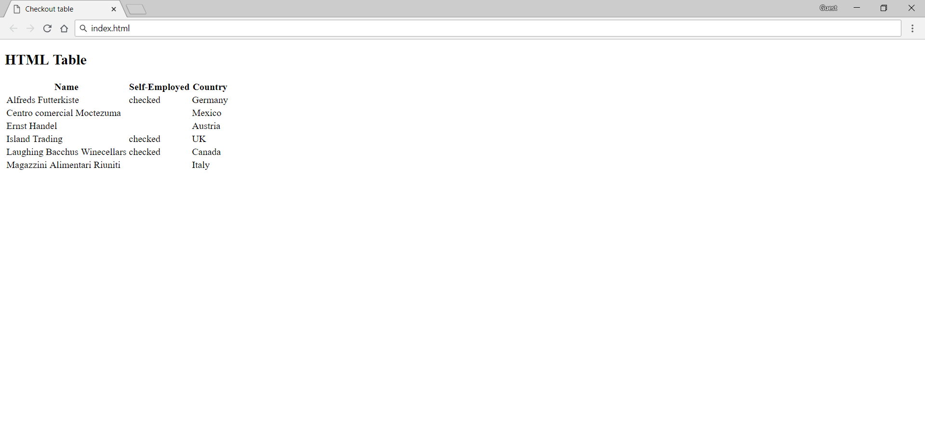

### Constraints

* Change the document **title** to Checkout tablе
* Use h2 tag for heading
* Use table tag to create a table
* Use tr tag for rows
* Use th and td tags for columns
* Use span tag with value checked for checked items